Barb&Vled Brokerage Company:
Information System Development Proposal

Scope of the project
While the Barb&Vled Company is a start-up company, the information system design project will include all stages of establishing an information system from identifying the needs, decision making, buying, installing and maintaining the information system. What is more, the IS design project should also cover suitable hardware, software, network and data solution for the company. Our company is responsible for an effective implementation of cross-functional enterprise system that will utilize information technologies.

Project goal
Barb&Vled Company is a brokerage company located in Trencin, Slovakia. The total number of employees at the company is 190. At this size the company needs to effectively maintain, process, and utilize the information in order to satisfy its customers, increase profits and establish a competitive advantage. The quick utilization of the data is crucial for a company that operates on stock and currency exchange markets. Therefore, the main goal is to establish an effective information system in the company that would utilize the data from stock markets, forex market and data analysis, support cooperation and collaboration of employees, and improve customer relations in order to increase profit. The situation analysis should be available to the other team members immediately in order to use the information wisely by investing operations.

System investigation stage
While the brokerage company would like to become a dominant player on the Slovak stock brokerage market, their management would like to utilize the newest information systems in order to get an advantage over its competitors and add value toward their customers. The first step is to summarize the advantages and disadvantages of the new information system by using the feasibility study and cost and benefit analysis.

Feasibility study
The proposed system would significantly improve the customer relationships, accumulating the information about the customers in order to predict their needs and requirements. Moreover, the system would offer immediate access to all major stock markets, with relevant information and data analysis. The data could be shared between the relevant employees offering collaboration opportunities in order to support winning decision making strategy. What is more, the important market decisions would be available to the employees anywhere, whether on road, at work, or at home. Moreover, the hardware and software solutions would be reliable, secure and scalable in order to support the growth of the company. The access to the new data, the collaboration system and the total availability anywhere could significantly increase the profits of the company, save the costs for additional labor force. Good results of the company supported by the new IS would attract more customers.
Cost and Benefit Analysis
Tangible benefits:
- Increase in sales and profits
- Increased efficiency of operations
- Elimination of paperwork
Intangible benefits:
- Online analytical processing
- Time efficiency
- Improved customer relations
- Fast availability of data related to market demand and currency value changes
Tangible costs:
- New hardware implementation costs
- New software implementation costs
Intangible costs:
- Initial implementation confusion of employees with new software and processes
- System dependency – in case the system collapses, the company would face serious risks

System analysis
System analysis presents the expected features defined by the customer and gives an overall picture what needs to be done and what attributes the system needs to contain.
Functional requirements
The Information system requirements, as specified by the Barb&Vled Company, are following:
- Improve the customer relations and customer satisfaction
- Save time and costs in comparison with standard procedures
- Support the decision making process
- Provide new data and analysis
- Compare new data with old data for trends
- Support communication and collaboration between the employees and customers
- The system should be user friendly, easy to learn, easy to operate and update
- The transactions performed should be fast and secure
- Offer fast computation potential and storage capacity
The Barb&Vled Company expects the new information system to be working within 2 months. The budget for this project is unlimited.

System design
User interface
The user interface of the solution is, so called, office oriented. While the dominant cross-functional system is Microsoft Dynamics, the user would face very well known interface from the other Microsoft products, such as Office. Moreover, the Microsoft Dynamics CRM system enables to implement and use the other Microsoft Products – such as Excell, Word, Outlook. It means, that the required training time for the employees would be significantly shorter in comparison with other solutions.
Software
The whole information system would be based on the cross-functional solution from Microsoft with 3rd party module for brokerage companies. This Microsoft Dynamics system combines financial market data, customer relationship management, and trading functionality with communication and collaboration techniques in order to get profitable and satisfy the customers. The Relevance X-stream module offers direct access to the trades, informations and financial data from Bloomberg and Reuters by utilizing the information by Microsoft BizTalk Server. Microsoft SQL Server would store the database of customers, financial operations, trends of stock and all the other relevant data. Moreover, each desktop and laptop computer in the company should have standard operation system Windows Vista and Microsoft Office package. And finally, in order to support interconnection of computers and connection to the internet, the company servers should include Microsoft Exchange Server, Microsoft Windows Enterprise Server, Microsoft SQL Server.
Software specifications:

Cross Functional System Solution:

001 x Microsoft Dynamics CRM 4.0 Server
Price: $ 5,487
100 x Relevance X-stream user module
Price: $ 1,096 X 100

Operation System:

180 x Windows Vista Business OEM
Price: 180 X 179 $

General Use Software:

180 x Microsoft Office 2007 Professional
Price: 180 X 399 $
180 x Eset Smart Security Business Edition
Price: 180 X 49 $

Network Server Solution:

1x Microsoft Windows Server Enterprise Edition
1x Microsoft SQL Server
1x Microsoft Exchange Server
1x Microsoft BizTalk Server
Price: Up to 25,000 $

Hardware specifications:
- Fast
- Secure
- Reliable

Equipment constellation

- 20 high end laptops for top management
- 50 mid-range laptops for businessmen
- 30 high end desktops for analysts
- 70 mid-range desktops for accountants, it people, and assistants
- 100 PDA for top management, analysts, and businessman
- 180 cell phones for everyone
- 180 cable phones for everyone
- 5 servers
- 3 switches
- 10 routers
- 1 storage
- 10 multifunction printer (fax included)
- 5 color laser printer
- 10 graphic calculators
- 10 security cameras
- 20 shredders

Network model

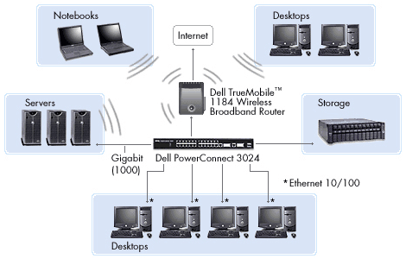

Server(x5): Dell PowerEdge™ 1955

Base: 2 X Quad Core Intel® Xeon® X5365

Warranty: 5Yr ProSupport for IT and 4hr Mission Critical

Memory: 32GB 667MHz 8X4-2R FBD

Hard disk: 2 X 73GB, SAS, 2.5-inch, 15.000 rpm Hard Drive

RAID: C1 Integrated SAS/SATA, No RAID, motherboard controller, min1/max2
Price: 14 000 USD (x5= 70 912 USD)

Switch(x4): PowerConnect 6248P ELITE

Price: 1 200 USD (x3= 3 600 USD)

Storage(x1) EqualLogic PS5000E iSCSI Array

16TB storage capacity

Price: 19 000 USD

Router(x10) Linksys WRT600N Wireless N Simultaneous Dual-band Gigabit Router

Price: 250 USD (2 500 USD)

Desktop for analysts (x30) Precision WorkStation T5400 Energy Star

Base: Quad Core Intel® Xeon® Processor X5460

Memory: 8GB, DDR2 SDRAM FBD Memory

Graphics: 512MB PCIe x16 nVidia Quadro FX3700, Dual Monitor DVI Capable

Monitors: 2 X Dell 24 inch UltraSharp™2408WFP Widescreen

Network card: Broadcom NetXtreme 10/100/1000 Gigabit Ethernet

Hard Drive: 500GB SATA 3.0Gb/s,7200

Wireless: Dell 1505 Wireless-N PCIe Card

Price: 9 018 USD (x30= 270 540 USD)

Laptops for top management (x 20)

Processor: Intel® Core™ 2 Duo T7500 (2.20GHz 4M L2 Cache, 800MHz) Dual Core

Screen: 17 inch Wide Screen WXGA+ LCD Panel

Video: NVIDIA® Quadro FX 1600M 512MB TurboCache (256MB discrete)

Memory: 1.0GB, DDR2-667 SDRAM, 2 DIMMS

Hard Drive: 80GB3 Hard Drive, 9.5MM, 5400RPM

Price: 1 849 USD (x20= 36 980 USD)

PDA’s for top management, analysts, and businessmen(x100):

Dell Axim X51v

Intel® XScaleTM PXA270 624MHz

Integrated 802.11b and BluetoothTM Wireless Technologies

Price: 290 USD (x100= 290 000 USD)

Laptops for businessmen(x50):

Processor Intel® Core™ 2 Duo T7250 (2.00GHz, 2M L2 Cache, 800MHz) Dual Core
Memory 1.0GB, DDR2-667MHz SDRAM, 2 DIMMS

Hard Drive 80GB2 Hard Drive, 9.5MM, 5400RPM

Price: 1 319 USD (x50= 65 950 USD)

Desktop for accountants, IT people, and assistants(x70)

Processor Intel® Pentium® Dual Core Processor E2160

Monitors Dell 19 inch E198WFP Widescreen Flat Panel, Analog

Memory 1.0GB DDR23 Non-ECC SDRAM, 667MHz, (1DIMM)

Hard Drives 80GB6 SATA 3.0Gb/s and 8MB DataBurst Cache™

Video Card Integrated Video, Intel® GMA3100

Price: 769 USD (x70= 53 830 USD)

Cell phones(x180) Nokia 6300

Price: 200 USD (x180= 36 000 USD)

Wire phones(x180)

RCA - ViSYS 2-Line Speakerphone

Price: 70 USD (x180= 12 600)

Projectors(x5) Sharp - XGA DDR DLP Projector

Price: 850 USD (x5= 4250 USD)

Multifunction printer(x10)

Dell Multi-Function Laser Printer 1125

Price: 200 USD (x10= 2000 USD)

Color laser printer(x5)

Dell Color Laser Printer 1320c

Price: 230 USD (x5= 1150 USD)

Network specifications:
The company would make a contract with T-com, for providing the internet connection. The internet connection is called T-Com Business net. This service is an excellent solution for creating an enterprise intranet with the internet connection. It provides permanent internet connection with guaranteed speed of 155 Mbit/s. One Business Net access point offers the access to Virtual Private Network, Internet, and Virtual Voice Net service. There are no capacity limits.
System implementation:
In order to get the information system running our company has to follow certain steps, such as acquisition, installation, training, checkout. The time limit for implementation was set at 2 months.The following time schedule was proposed:
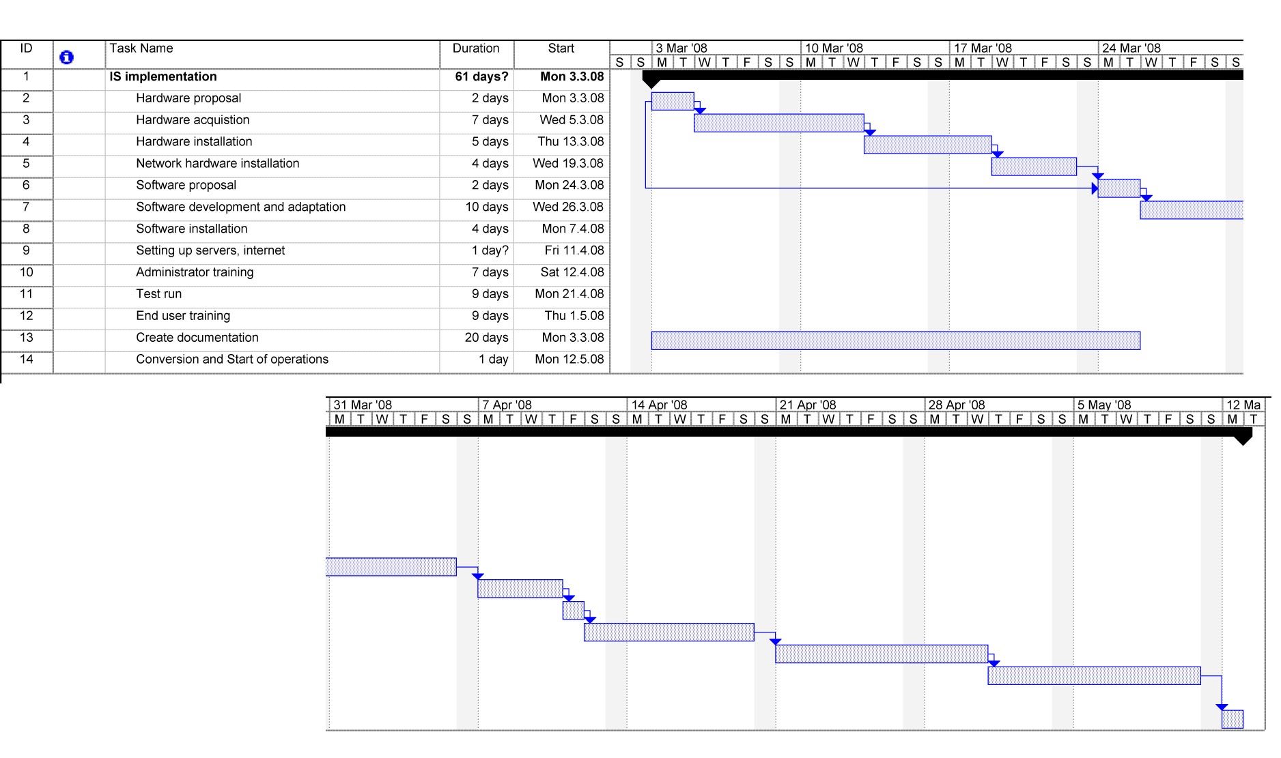
System maintenance:
- All the administrators would be trained to perform basic daily database maintenance
- There would be regular checks of the information system performed by our company every 3 weeks
- There would be an Intranet web page where the employees could post their ideas and suggestions for improvement of the system interface
- Our company would offer 24 hour online help center
- All the necessary modifications of the system must be discussed with our company
- The administrators has to monitor the individual functions of the system

Evaluation for IS Services:
In order to see the overall effectivity of the implemented system, it is vital to evaluate the information system in all its stages and factors. The evaluation process could highlight the weak places of the system that has to be updated or upgraded in order to reach the requested efficiency. There are various evaluation factors:
Performance
- The overall speed of the system is up to the expectations
- The capacity of the storage system is easy to upgrade by additional HDDs
- The system is able to manage the operations of all 180 employees
- The system supplies all the necessary data
System development
- Our company would be able to update or expand the system
- The scalability of the IS would keep the system effective for another 70 users.
Maintenance
- The system administrators will be properly trained for maintenance
Conversion
- While the company is start-up, there is no need for data conversion from previous years
Training
- The training is divided into 2 stages : training of administrators and training of the end users. Appropriate manuals would be available. New employees would be trained by the administrators.
Backup
- The internet connection is secured with 2 links, 1 of them is backup
- All the data would be saved also on the backup drives
- Our company offers immediate nonstop service in case of emergency
Software
- The CRM cross-functional system from Microsoft in combination with the Relevance X-stream module have been successful in number of cases of international stock-brokerage companies.
Hardware
- The hardware solution offers hot up-to-date technologies created by high quality supplier – Dell, with long history of successful solutions.

References:

Autocont. (2008). Microsoft product overview. Retrieved February 18, 2008, from http://muj.autocont.cz/prehled.aspx?v=MICROSOFT
Dell. (2008). Dell technology. Retrieved February 18, 2008, from http://www.dell.com/
ESET. (2008). Eset smart security edition. Retrieved February 18, 2008, from http://www.eset.sk/cenniky/eset-smart-security-business
Linksys. (2008). Basic networking. Retrieved February 18, 2008, from http://www.linksys.com/servlet/Satellite?c=L_Product_C1&childpagename=US%2FLayout&cid=1115416939789&pagename=Linksys%2FCommon%2FVisitorWrapper&lid=3978991233B01
Management Technology Consulting LLC. (2008). Microsoft Dynamics CRM Software. Retrieved February 18, 2008, from http://www.mtccrm.com/Microsoft-CRM-Products/default.asp#Users
Microsoft. (2008). Microsoft Dynamics CRM. Retrieved February 18, 2008, from http://www.microsoft.com/dynamics/crm/default.mspx
Microsoft. (2007, July 9). Relevance Software. Retrieved February 18, 2008, from http://www.microsoft.com/dynamics/casestudies/financialservices.aspx?casestudyid=4000000359
Nokia. (2008). Nokia 6300. Retrieved February 18, 2008, from http://www.nokia.sk/ link?cid=PLAIN_TEXT_237779
T-Com. (2008). Business Net. Retrieved February 18, 2008, from http://www.telecom.sk/ Default.aspx?CatID=855&Section=business

